Methods

**DNA Sequencing**

We collected blood samples from three species of Darwin’s finch in 2019: the medium ground finch (*Geospiza fortis,* N=8), vegetarian finch (*Platyspiza crassirostris,* N=9), and the small tree finch (*Camarhynchus parvulus*, N=7). We sequenced the whole genomes on Illumina … # get sequencing info from Sabrina, to an average depth of ~9x coverage. These samples constitute our “post invasion” treatment, and were taken 21 years or 3.5-7 finch generations after the fly was first recorded in an avian nest in 1998 (CITE). We also accessed published whole genome sequence data (also ~9x coverage) from samples taken in the 1980s and 1990s from these same species with respective sample sizes of N=10, 5, and 12. These samples constitute our “pre invasion” treatment.

**DNA Processing**

To assess and address potential batch effects between the genomic datasets in our pre and post treatments, we carefully followed guidelines for data processing to ameliorate batch effects outlined in Lou et al. (CITE). We also prioritized analyses that leverage genotype likelihoods where possible, but given that the average depth of our samples is sufficient for accurate genotype calls (CITE), we also used programs that require genotype calls in circumstances where no comparable method that uses a likelihood framework is available.

We trimmed adapters from the raw sequence fasta files using Trimmomatic. We then trimmed polyg tails with a minimum poly-g length of 10 in the program fastp. Following this, we trimmed for length and quality using Trimmomatic with the settings LEADING:20 TRAILING:20 SLIDINGWINDOW:4:20 MINLEN:90. We assessed sequence data using fastqc at each step.

We then aligned files using bowtie2 to the chromosome level *Camarhynchus parvulus* STF-HiC reference genome (1.28 GB;Genbank accession number: GCF_901933205.1), converted the output to bam files, and sorted each bam file in samtools. We clipped overlapping read pairs using the function clipOverlap in bamUtil and we realigned around indels using gatk (3.7-0). Finally, we added read groups using the AddOrReplaceReadGroups function in picard. We then curated a list of SNPs for use in downstream analyses in angsd using the default SNP p-value cutoff of 1e-6, minimum quality and mapping quality scores of 30, and minimum minor-allele frequency of 0.05.

To address biases that may influence analyses that rely on genotype calls, we first analyzed the reference genome for low mapability scores using snpable, created one vcf files per individual using bcftools mpileup and call, masked out sites with low mapability scores, phased each vcf using whatshap, sorted and indexed each file using bcftools, and combined vcfs by species and treatment (pre vs. post).

**DNA Analysis**

We assessed population structure of our samples using a principal component analyses implemented in PCAngsd, which confirmed species clusters and showed no bias by treatment. For all windowed analyses, we eliminated windows with either an average depth of coverage or average mapability below or above 2 standard deviations from the mean. We tested for selection between our two time points by analyzing FST, Tajima’s D, and change in allele frequency across the genome using angsd. For FST and Tajima’s D, we performed overlapping windowed analyses using 50,000 base pair windows with a step size of 12,500 base pairs. For FST, we directly compared pre- and post-invasion treatments within each species. We computed the difference in Tajima’s D by subtracting the value estimated in each window from the pre-invasion treatment from the value estimated in the post-invasion treatment. We analyzed change in allele frequency at individual sites. We identified outlying regions and sites as those within the outlying 1% of regions. For FST we looked at the top 1%, and for Tajima’s D, we considered the bottom 1% of regions, as a strong negative shift in Tajima’s D indicates a recent selective sweep. We also looked for relaxed selection on previously swept genes by looking at the top 1% of windows for the difference in Tajima’s D, as a strong positive shift in Tajima’s D indicates diversification at a previously swept region. For each analysis, we curated lists of genes that overlapped with any outlier windows. # How did we identify genes from deltaAF, since those are only sites?

Additionally, we performed two tests of selection that rely on genotype calls. We looked for regions that have experienced recent selective sweeps by analyzing pre- and post-invasion treatments separately in RAiSD. To identify only selective sweeps that have occurred between the introduction of *P.* *downsi* and our sampling in 2019, we only considered genes that were uniquely within outlier windows in the post-invasion treatment and not within any pre-invasion treatment outlier windows. Finally, we used Timesweeper # explain more once it is done.

To test for evidence of parallel evolution across species, …

**Results**

**Population structure**

**Selection – Manhattan Plots**

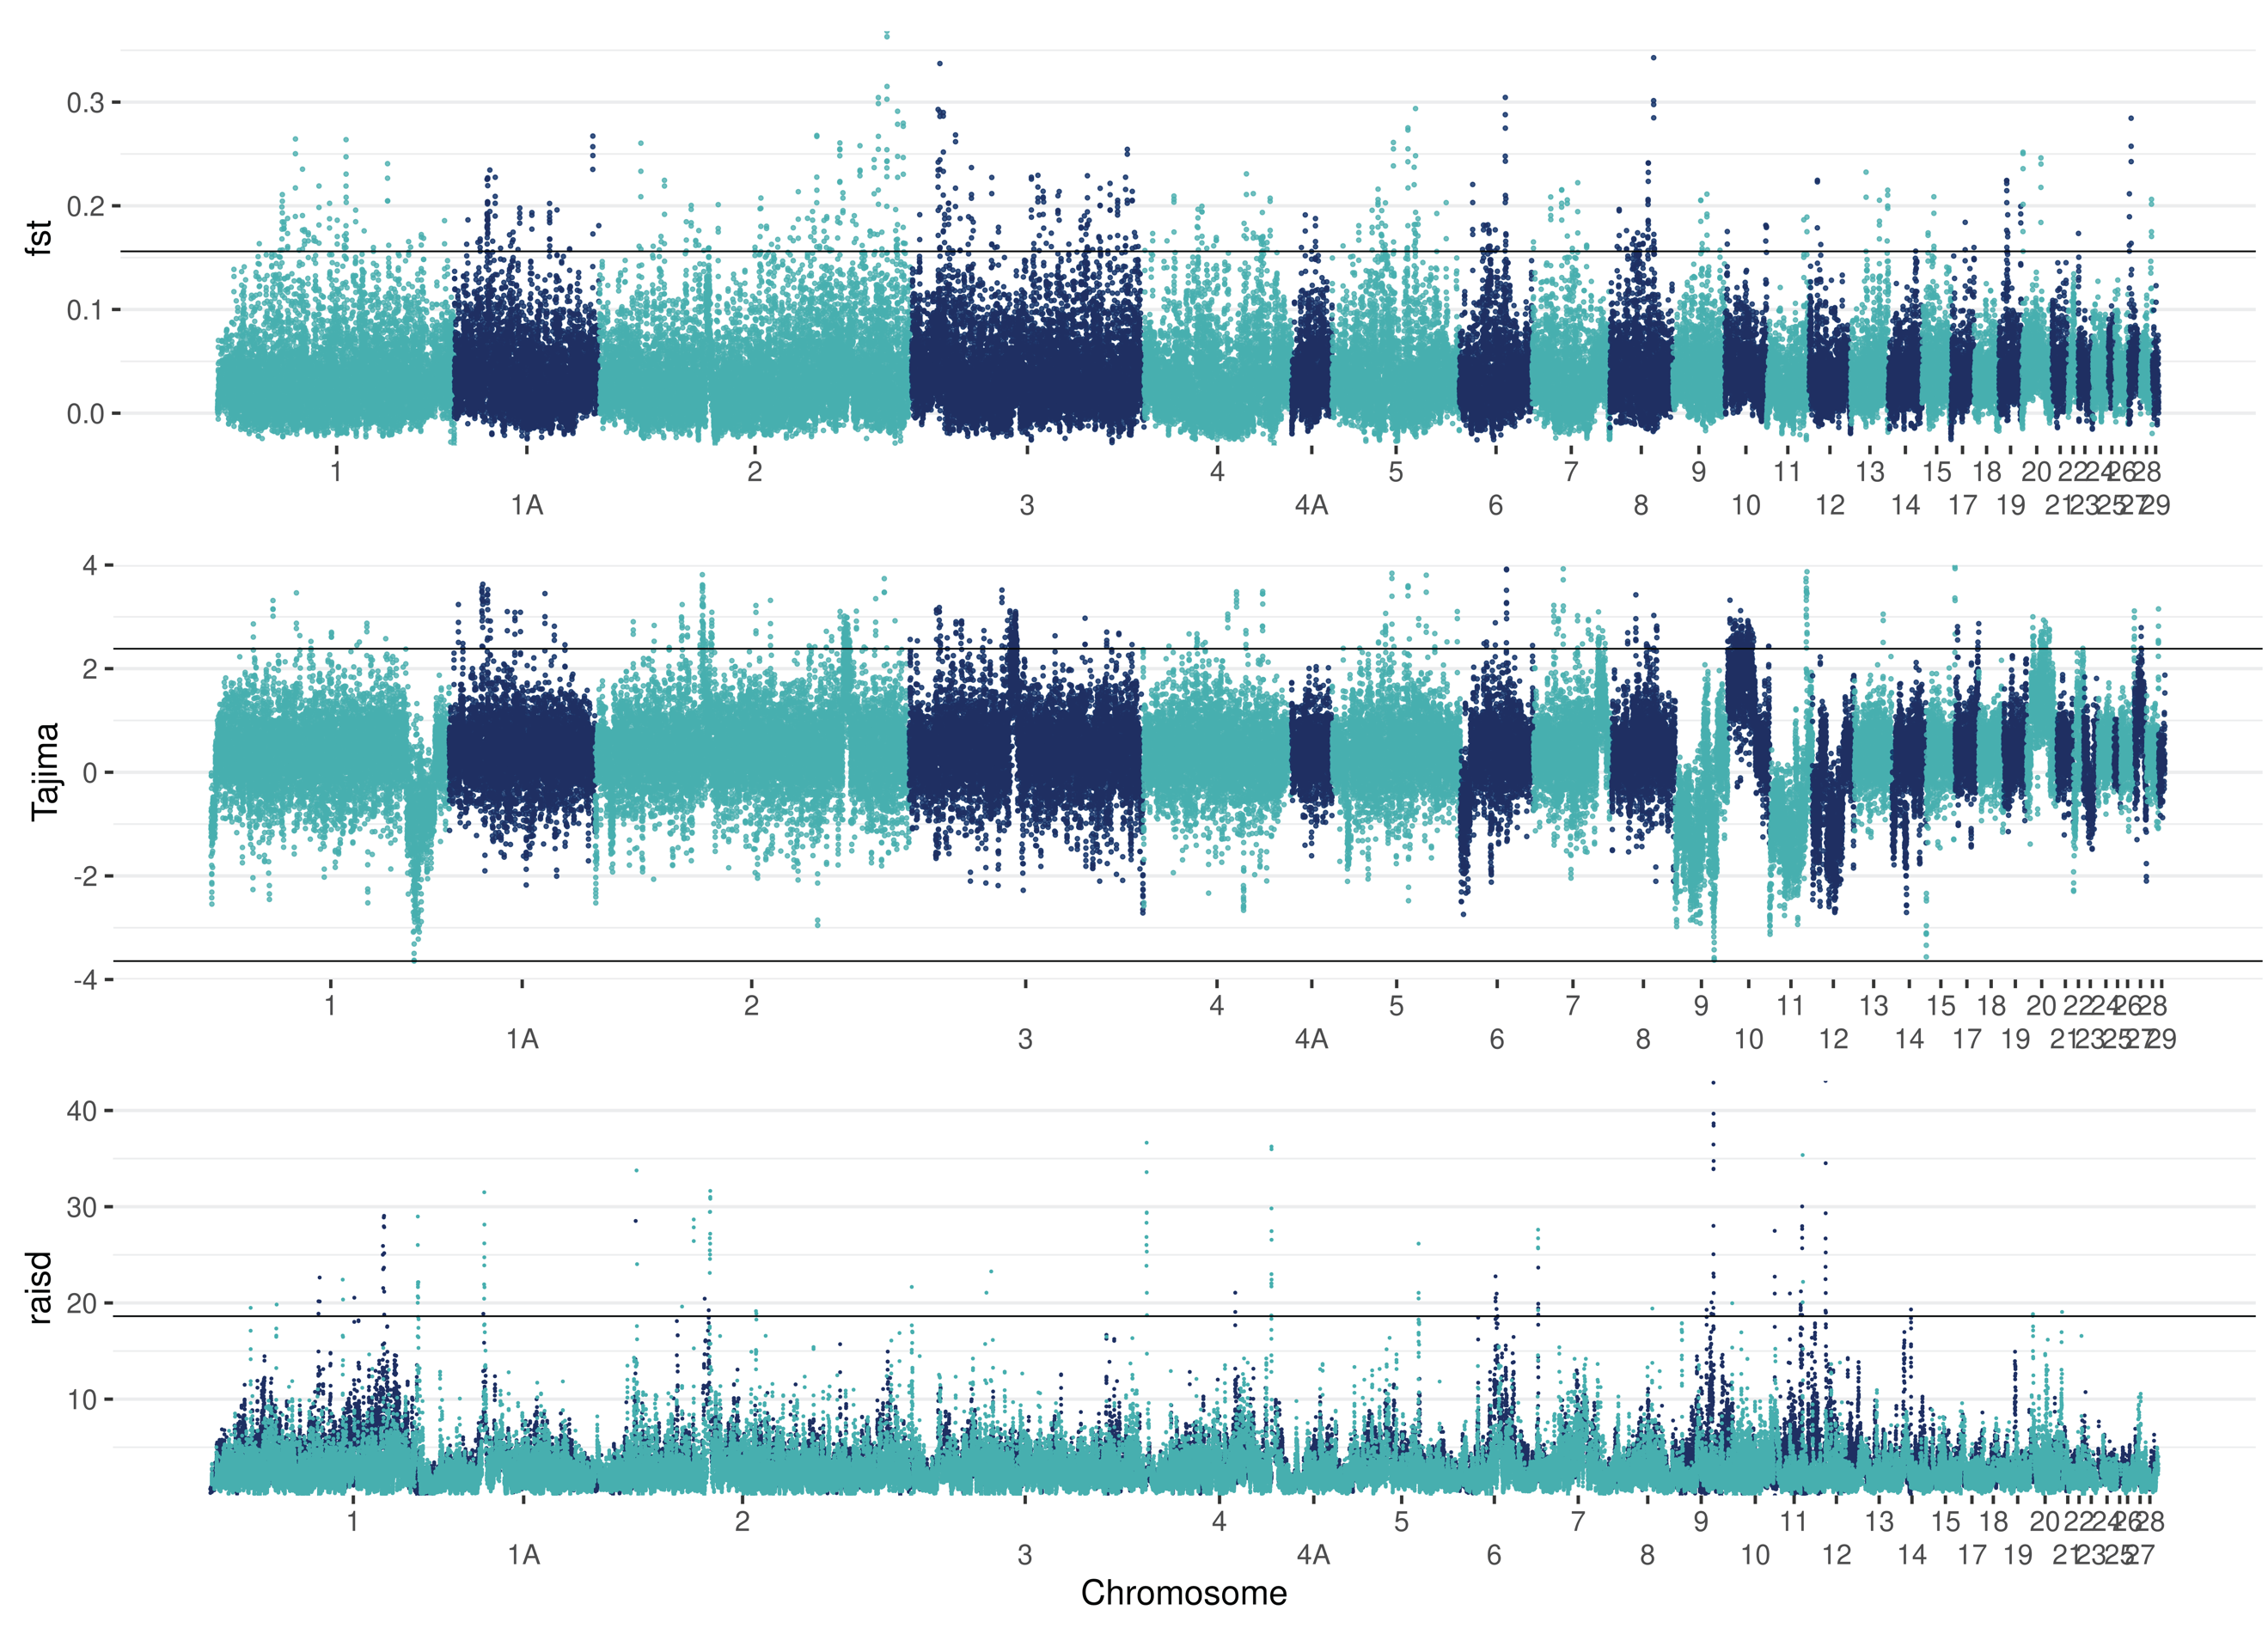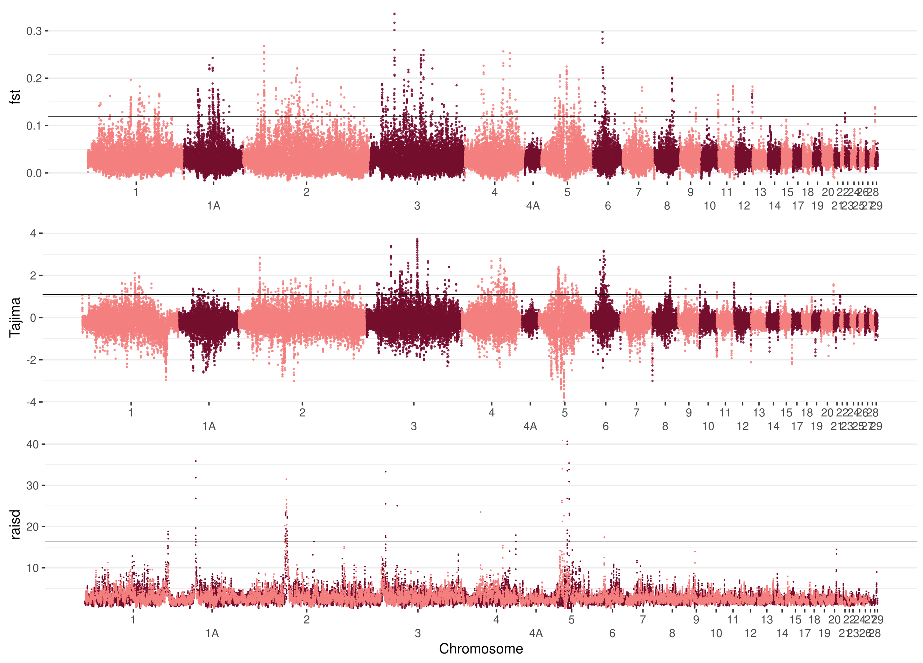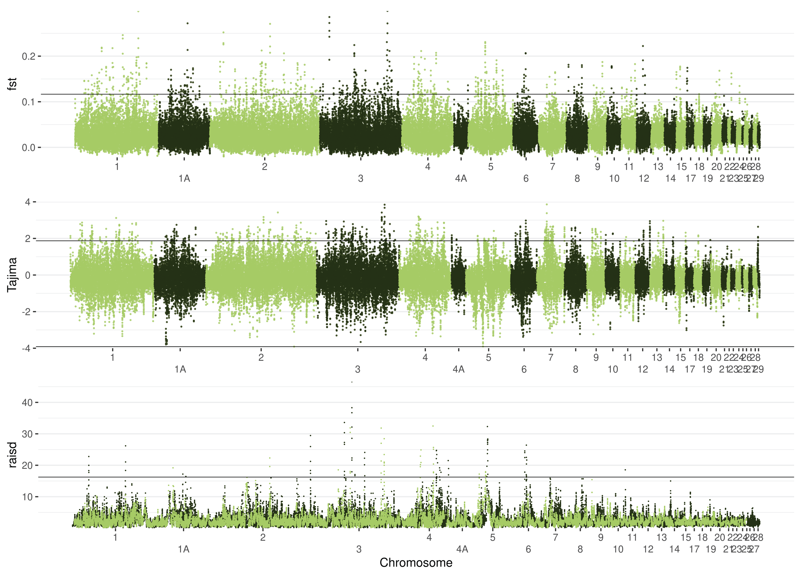

**Selection – GO terms**

